CAT DATA SHEET

Make: Total Tube Length: ’ ”

Model: Measured by: Customer

Year: Date Measured: / /

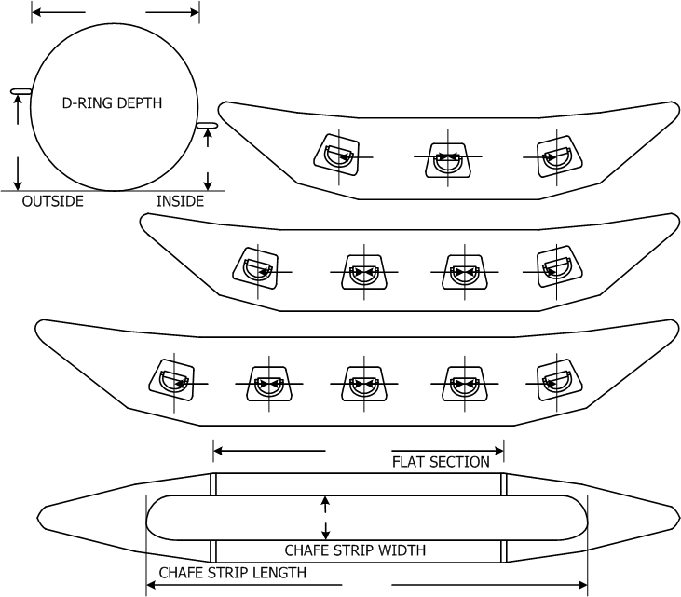
”

# of D-Rings: (use appropriate drawing below)
TUBE DIAMETER

”
” ” ”

” ” ”

” ” ” ”

”

”

”

